assignmentsample

FortnaPlus Control
Shifter and Sorter Configuration
Document Revision: 1.6
Date: 21-Sep-2022

Revision | Date | Author | Revision Summary
1.0 | 18-Apr-2013 | B C Conklin | New document
1.1 | 14-Jul-2014 | B C Conklin | Details on DontSetExpect and ArmFriend configurations
1.2 | 27-May-2015 | B C Conklin | Add columns for recirculation rate management to table Sorters
1.3 | 09-Dec-2015 | B C Conklin | Add trigger features in table Sorters
1.4 | 02-Mar-2021 | T R Kremser | Updates and general refresh
1.5 | 01-Dec-2021 | T R Kremser | Clarify examples for ArmFriend, UseArmed, DontSetExpect.
1.6 | 21-Sep-2022 | T R Kremser | Add note about Encoders_Encoder_I_O using a part owned by SORT

Table of Contents
1. Shifters and Sorters 5
1.1. Sizing a Shifter 6
1.2. Sizing for Shifter Contents 7
1.3. Setting the Induct Photoeye Location 7
1.4. Dump Points and Multiple Shifters 8
1.5. Gridlock Protection 8
2. SortData and SortBuff Tables 9
3. Sorters Table 10
4. Inpoints Table 14
5. Updates Table 16
6. Outpoints Table 16
6.1. Setting Dwell 21
6.2. DontSetExpect and Shoe Sorters 22
6.3. Two-Solenoid Divert 22
6.4. Three-Solenoid Divert 23
6.5. Retent Details 24
7. Encoders Table 25
8. Graphical Shifters Window 28
8.1. Simulation Tools 29
8.2. Points Info Tab 30
8.3. Boxes Info Tab 31
8.4. Color Codes Tab 32
8.5. Points Info Tab – Sorter 32
8.6. Additional Shifter Examples 33
9. Shift Print Log Messages 34
9.1. SFTPRNT Events 36
9.2. Update Events 37
9.3. Verify Events 37
9.4. DUMP Events 38
9.5. SrtBadGapProcessing Events 38
9.6. HSSawMerge Events 39
9.7. Collision Events 39
9.8. Sawtooth Events 40
9.9. Zpr Stop Events 40
9.10. Shift Print Alignment 40
10. Interpreting CTRL and SORT Log Data 41
11. Divert-Confirm Options 43
11.1. Configuring a Divert-Confirm Photoeye 44
11.2. Divert-confirm Result Codes 46

Confidential/Proprietary Statement
This document contains trade secrets and information that is considered confidential and proprietary to Fortna, Inc. It may not be duplicated, used, or disclosed outside the original recipient organization, and it may not be duplicated, in whole or in part, for any purpose other than to evaluate this document. Fortna Material Handling reserves the right to modify this document as necessary to reflect any terms and conditions negotiated and included as part of a subsequent contract or purchase order.

Glossary of Terms
AC – Automation Controller
DCM – Divert Confirm Message
FPC – FortnaPlus Control

Shifters and Sorters
Shifters are logical constructs that form building blocks for sorters and merges. Shifters track a virtual image of each container as it moves along a physical section of conveyor. Data generated by events such as barcode scans and scale readings and assignment of lane destinations are “attached” to the logical container image and used to control how it is handled.
Shifter Diagram
Divert Points
(Outpoints)
Induct Point
(Inpoints)
(Updates)
DUMP
Point
Update Point

A shifter represents a section of conveyor with some combination of Induct, Update and/or Divert points, plus a Dump point. The Induct point uses an induct photoeye to measure the container length as it enters the shifter and create storage space for data that will be associated with it as it passes along the sorter (a tracking record). Update points represent positions where additional data may be attached to the container image, such as scans, scale readings and dimensions. Divert points are used to trigger mechanisms to direct containers to another path. A Dump point occurs at the end of a shifter if the container will move to another shifter. The data gathered for a container in the upstream shifter is transferred (or dumped) to the downstream shifter. Another photoeye (dump eye) is used to re-measure the container and create the new image of the container on the new shifter – similar to the induct eye.
The sorter control module uses shifters to construct a representation of a sorter that will handle the container images, manage tracking, monitor gapping, and detect and handle events such as induction of new containers, diverts, and transitions from one shifter to another (dumps).
The merge modules use a shifter to represent the “merge bed” and to track the positions of each container so they can be interleaved.
A shifter is a logical abstraction of a physical section of conveyor. It can be thought of as a ruler along which we measure the motion of the containers. The units for the scale of this ruler are called ticks, and represent distance along the shifter, and, as the conveyor will run at a certain rate, can also be thought of in terms of time.
Ticks are most often measured by an encoder device that is configured to emit a pulse each time the conveyor moves a certain distance. They are usually rotary encoders, so they are configured for a certain number of pulses per turn, which translates to a certain linear distance on the conveyor surface through the gears and pulleys that move the conveyor belt.
Example: (100 inches per encoder turn) / (100 pulses per turn) = 1 inch per tick.
Shifters can alternatively be driven by a timer that produces a tick for each interval. Each tick advances the positions of containers on the shifter. Each timer tick represents distance traveled by the conveyor belt at a certain speed.
Example: (40 inches per second) * (0.025 seconds per tick) = 1 inch per tick.
Timer encoders are useful when a rotary encoder is not available, and function in much the same way, though they cannot account for the mass of the conveyor during start and stop, so they will not track the motion of the physical containers as well – getting ahead of the physical during startup and lagging behind when stopping.

Sizing a Shifter
Following our ruler analogy, a shifter must be defined to have a length, in ticks. The size is determined based on the physical length of the conveyor section and the resolution of the encoder. If the section of conveyor is 100 feet, or 1200 inches long, and the encoder has a 1 inch per tick resolution, it would be 1200 ticks long. The shifter representing this section will need to be at least that long. It is best to define the shifter with some extra space. A good rule of thumb is to allow 30% extra, then round up to the next 500 ticks, so we would make this shifter 1200 + 360 = 1560 2000 ticks long. This value will be configured in the Sorters table and used by the SortBuff table, as described below.

Sizing for Shifter Contents
A shifter can physically hold up to a certain number of containers. The shifter needs to have enough space defined to track the data for the containers that will fit on it. To determine this value, you need the length of the shifter, the length of the smallest container and the expected minimum gap between containers. If our 1200-inch shifter will carry containers as small as 10 inches with a minimum 10-inch gap, we would have:
(1200-inch shifter) / (10-inch container + 10-inch gap) = 60 containers
Once again, we will allow 30% extra, so 60 + 18 = 78, and round up to the next 100 for a value of 100 containers.
This value will be entered in table Sorters, column Max Cartons and used to configure the space allocated in the SortData table, as described below. Max Cartons is only used by the sorter configuration wizard. The Data_LowRec and Data_HighRec values determine the actual allocated space.
NOTE: When constructing a sorter from multiple shifters, the number of containers defined for each shifter must be set to the value calculated for the largest shifter.

Setting the Induct Photoeye Location
The induct photoeye for a shifter must be physically located so the largest container will be at least three quarters of the way onto the belt when the beam is broken. This ensures that the container is moving with the belt as it is inducted and will be tracked accurately. This also helps prevent tracking errors if the upstream belt should stop and allow a container to drift part-way onto the shifter.
As containers are dumped onto successive shifters (explained below), the extra logical length we have defined in SortBuff will ensure the data is carried to the next induct point – the shifters logically “overlap” to allow this.

Dump Points and Multiple Shifters
Physical sorters and merges are created using multiple segments of conveyor. Using multiple shifters to logically represent these physical components produces the most accurate tracking.
In the case of sorters, multiple shifters may be linked together by dump points. As the containers physically pass these dump points, the data representing them in the logical shifter image is “dumped” to a new image on the next shifter. The induct photoeye on the next shifter physically re-measures the container, helping to keep the physical and logical in synchronization. This helps to compensate for small speed differences and slippage as containers transition across the belts. This can be particularly important on print-and-apply systems where the label tamper may push the container out of position.
The logical container image must arrive at the dump point (“be over the dump point”) and correspond with the physical container activating the induct photoeye for a successful dump to occur. If the container and the logical image do not arrive together (within one container length) at the next induct photoeye, the dump will not occur, and the data will be lost. The data will also be lost if the dump induction photoeye does not activate.

Gridlock Protection
Sorters with recirculation are comprised of a loop with a sorter and a merge. The recirculation line may include some accumulation conveyor, but the storage space is limited. If new containers arrive at the merge faster than the sorter can process them, gridlock will occur when all the space on the sorter loop is consumed, forcing the loop to stop. Manual intervention is then required to clear enough space for the sorter to start again. To protect against this, it is necessary to monitor the recirculation rate and use that information to limit new input at the merge.
The sorter control module has options to monitor recirculation rate and use the information to throttle new input at the merge. Use of this feature is essential to allow the sorter to “catch up” on processing recirculating containers before new containers are introduced at the merge.
The Sorter Control module works with the Rate Process module and the RateCount table to manage this, based on recirculated containers resulting from full destination lanes.

SortData and SortBuff Tables
While you do not need to do anything with these internal tables directly, understanding their function is important to understanding how shifters work in the context of sorters.
Table SortData is used to contain information necessary for handling each container while it is being tracked on all the shifters on an AC. Each shifter is assigned a range of rows within table SortData using the Data LowRec and Data HighRec fields in table Sorters. Table SortData holds the information about lane assignments, how long to fire the diverts (dwell), and DCM status. This is the data that is “dumped” from shifter to shifter as the container moves along a sorter.
Table SortBuff is the “shift register” that represents an “image” of each container as it moves along each shifter on the AC. Each shifter is assigned a range of rows within table SortBuff using the Buffer LowRec and Buffer HighRec fields in table Sorters. Table SortBuff holds only the tick position along each shifter, a reference to the associated SortData record for the container, and a reference to the associated shifter. A container “image” appears as consecutive tick positions all referencing a particular row in SortData, as measured by the induct (or dump) photoeye. The empty space between containers is indicated by -1 for the SortData_Index references. The entire section associated with a shifter advances (or shifts – hence the name) with each tick of the encoder.
NOTE: It is vitally important for proper operation that the range of rows assigned to each shifter in these tables do not overlap!

Sorters Table
Table Sorters is the top-level configuration for shifters. Each record represents a shifter. Shifters can be linked together to form a sorter.
Sorters Table
Field | Type | Description
Sorter Name | String | Enter a unique name for this shifter.
Encoder ioName | PopUp | Select the associated record from the Encoders table. The Encoders record defines the input from a rotary encoder device in field Encoder I/O. It provides performance data for both rotary encoders and timer-based encoders. See section 7 for additional detail on pulse position rotary encoders.
Encoder tmName | PopUp | If you wish to use a timer-based encoder, select a timer from the timemenu table.
Encoder Type | Int | Set to 0 to use a rotary encoder.  Set to 1 to simulate an encoder using a timer.  Use a timer-based encoder if a physical encoder device is not available. If used with a timer-based encoder, the Encoders record will indicate the calculated speed of the shifter. If Encoders EnableBit is defined, it will be used to start and stop the timer. The Encoders DupToMemBit field can be used to create a synthetic encoder signal from the timer, if needed.
pStatus | String | Update by the software to indicate errors detected in the configuration.
Max Cartons | Int | This value is only used by the sorter configuration wizard. The results are used to set Data_LowRec and Data_HighRec. Enter the maximum number of containers that can be tracked on the shifter. Calculate the appropriate value as described in section 1.2
Max Verify Buffer | Int | Set by the sorter configuration wizard to the same value as Max Cartons. Not used.
Dump NDX | Int | Enter the index value (row number in this table) of the next shifter in sequence if this shifter should dump to another shifter. A sorter can be composed of a series of shifters in this way. If this is the last shifter in the sequence, set this value to -1.
Dump OUT | Int | Set the tick position on the shifter where container data will dump to the next shifter – also known as the “Dump Point”. Use the SFTPRNT lines in the SORT log file to aid in finding the correct position. This value can also be adjusted from the DUMP point in the Graphical Shifter window.
Dump IN | Int | Usually set to 0. This is the row index number from the Inpoints table for the induct photoeye of the next shifter (the one to which this shifter dumps). If the next shifter has only one induct point (the usual case), set this value to 0.
UseFirstShifterNdx | Y/N | If this shifter is part of a sorter with multiple shifters, and it is not the first one in the chain, set this to Y. It helps to protect against invalid tracking data for improperly dumped containers by assigning a SortData tracking record based on the LastNdx value from the first shifter in the chain.
LastNdx | Int | Set by the software to record the last data record used.
OK | Y/N | Set to Y to activate this shifter. Can be set to N to disable the shifter during configuration changes.
ShiftOnOff | Y/N | Set to Y to effectively double the resolution of the encoder. Both the rising and falling edge of each encoder pulse will be used to shift the shifter. Changing this may require re-timing of all diverts and dump points, though the software attempts to adjust them for you.
Machine | PopUp | Select the AC that will control this shifter.
ManualShift | Y/N | Set this to Y to advance the shifter by one tick. The software will reset it to N. This field is used by the Graphical Shifter window when Alt-S is used to simulate an encoder tick.
Shifted | Y/N | Set by the software to indicate the shifter has been advanced.
Data LowRec | Int | Set this to the starting record position for this shifter in table SortData. Each shifter on the AC requires a block of records to hold the data for containers currently on the shifter as determined in section 1.2. Set this to 1 for the first shifter on the AC. Make sure the blocks of records for each shifter do not overlap.
Data HighRec | Int | Set this to the ending record position for this shifter in table SortData. Each shifter on the AC requires a block of records to hold the data for containers currently on the shifter as determined in section 1.2. Make sure the blocks of records for each shifter do not overlap.
Buffer LowRec | Int | Set this to the starting record position for this shifter in table SortBuff. Each shifter on the AC requires a block of records to define an “image” of the containers currently on the shifter as determined in section 1.1. Set this to 1 for the first shifter on the AC. Make sure the blocks of records for each shifter do not overlap.
Buffer HighRec | Int | Set this to the ending record position for this shifter in table SortBuff. Each shifter on the AC requires a block of records to define an “image” of the containers currently on the shifter as determined in section 1.1. Make sure the blocks of records for each shifter do not overlap.
Inpoints LowRec | Int | Set this to define the row number of the beginning of the range of rows in table Inpoints associated with this shifter. A shifter for a sorter will usually need only one induct point. A shifter for a sawtooth merge requires an induct point for each lane.
Inpoints HighRec | Int | Set this to define the row number of the end of the range of rows in table Inpoints for this shifter.
Updates LowRec | Int | Set this to define the row number of the beginning of the range of rows in table Updates for this shifter.
Updates HighRec | Int | Set this to define the row number of the end of the range of rows in table Updates for this shifter.
Outpoints LowRec | Int | Set this to define the row number of the beginning of the range of rows in table Outpoints for this shifter.
Outpoints HighRec | Int | Set this to define the row number of the end of the range of rows in table Outpoints for this shifter.
ShiftCnt | Int | Incremented by the software each time the shifter is advanced. It will reset to 0 after reaching 999. This can be used as a diagnostic indication.
TrigOnOnly | Y/N | This field is used to control the behavior of divert outputs for shoe sorters with a proximity switch or photoeye at each divert position. It is used in conjunction with TrigTransOn, and TrigTransOff and with Outpoints Trigger I/O Name (henceforth, the trigger), and TrigWndwTicks. The proximity switch detects if the shoe pin is in the correct position to allow the divert mechanism to be fired or un-fired safely. Dwell settings are honored to determine how long the divert is fired.  NOTE: All actions described will occur only within the tick window defined by TrigWndwTicks. The divert will not be fired when the container is outside the window. (In older versions, the trigger was not limited by TrigWndwTicks).  NOTE: The settings of TrigTransOn and TrigTransOff determine if this field will act on the steady-state of the trigger (ISON/ISOFF) or the transition of the trigger (TRANSON/TRANSOFF).  N: FIRE and UNFIRE of divert can happen only while the trigger is ON.  Y: FIRE can happen only while the trigger is ON. UNFIRE can occur regardless of the state of the trigger.
TrigOnOff | Y/N | Not used
TrigTransOn | Y/N | TrigTransOn and TrigTransOff allow selection of three different methods for determining how to fire diverts. Each of the three methods are further divided by the setting of TrigOnOnly, which alters the behavior of the UNFIRE. The input defined in Outpoints Trigger I/O Name is referred to as “the trigger”, below.  TrigTransOn TrigTransOff Behavior  N N FIRE only if the trigger is ON UNFIRE as defined by TrigOnOnly and the ISON / ISOFF state of the trigger.  Y N FIRE only on TRANSON of the trigger UNFIRE as defined by TrigOnOnly and the TRANSON / TRANSOFF state of the trigger.  N Y FIRE only on TRANSOFF of the trigger UNFIRE as defined by TrigOnOnly and the TRANSON / TRANSOFF state of the trigger.  Y Y Not defined – no action will occur
TrigTransOff | Y/N
TrigWndwTicks | Int | This value is used for shoe sorters to define a limited range of tick positions relative to the divert point within which a divert trigger signal must come on in order to fire the divert. The Outpoints Trigger I/O Name signal can be used as a pin detection signal for shoe sorters. A pin must be detected within the window defined by this value to safely fire the divert and avoid damage to the sorter mechanism. If the Outpoints Set Fixed Delay or Percent Box Delay columns are used, they must be added to this value.
DivertEnableIO | PopUp | If needed, select an IO part to indicate if diverts are enabled for this shifter.
InvertEnableIO | Y/N | If a part is selected in DivertEnableIO, this field determines how its state will be interpreted:  Y: Diverts are disabled if DivertEnableIO is ON  N: Diverts are disabled if DivertEnableIO is OFF
RecircRate | PopUp | Select and entry from table RateCount that will measure the recirculation rate on the sorter. Do not select a CountIO signal in the RateCount entry when used this way.  CntRecircWhenFull and RecircRateUpdPt determine how the rate is measured.  RateCount CountNow is incremented each time a divert failure is recorded.
CntRecircWhenFull | Y/N | Determines how / where divert failure events are counted:  N: Divert failure events are counted when the container reaches the RecircRateUpdPt. This creates a consistent point to count all recirculation containers instead of being spread out across the shifter. This is the preferred setting. The RecircRateUpdPt must be located after the last divert on the shifter, but before the end of the shifter.  Y: Divert failure events are counted as the container passes the lane. Only “Bad Gap” containers are counted at the RecircRateUpdPt.
RecircRateUpdPt | PopUp | Choose the update point where divert failure events will be recorded.  If CntRecircWhenFull is set to N, the update point must be located after the last divert on the shifter, but before the end of the shifter and will be used to record all divert failure events for the shifter.  If CntRecircWhenFull is set to Y, the update point can be located anywhere on the shifter from just prior to the first divert, but it will only be used to record “Bad Gap” events.
pDumpFrom | Int | Used by the software to indicate the row of the shifter that will dump onto this shifter based on the DumpNdx value of the other shifters.
pDumpOffset | Int | Used by the software for dynamic reassignment internal calculations.
pLastDumpLoc | Int | Used by the software for dynamic reassignment internal calculations.
pFirstShifter | Int | Used by the software to determine the first shifter in a linked chain of shifters comprising a sorter. Used internally when inducting containers.
pLastShifter | Int | Used by the software to determine the last shifter in a linked chain of shifters comprising a sorter.
pMaxNdx | Int | Used by the software at startup to check the size of each shifter associated with a sorter. The value is set to the size of the smallest shifter for use with SortData records.

Inpoints Table
Table Inpoints defines tick positions on a shifter where a container will be inducted, known as induct points.
NOTE: Restart FPC after adding induct points to make them available for use. Do not use record zero.
Inpoints Table
Field | Type | Description
Inpoint Name | String | Enter a unique name.
Sorter | PopUp | Select the shifter associated with this induct point.
Induct Number | Int | Set by the software. Each induct point for a shifter is numbered sequentially in the order found in the table, starting with 0. Most often, sorter shifters will be 0 (single induct point), while sawtooth merge shifters will have an induct point for each lane.
Induct Location | Int | Set the induct point location on the shifter, in ticks – usually 30. This must be set to a value large enough to accommodate the Trailing_Edge_Pad value, which is added in SortBuff when the induct photoeye goes OFF.
Induct I/O Name | PopUp | Select the induct photoeye IO part.
Trailing_Edge_Pad | Int | Set the number of ticks to be added to the end of the container image when the induct photoeye goes OFF.
Minimum Gap | Int | Set the minimum distance between containers, in ticks. The Minimum Gap is measured from the end of the Trailing_Edge_Pad to the nose of the next container. Containers will not be diverted if the minimum spacing is not met.
Longest Package | Int | Not used.
Data | Int | Used by the software. Holds the SortData record number that will be used on the next container to be inducted. When the next container arrives at the induct point, the value is copied to CurrData, then set to -1 before the next record is assigned.
CurrData | Int | Used by the software to hold the SortData record number of the container currently being inducted. When the induct photoeye transitions on as a container is being inducted, the value in Data is copied here and used to identify the container while it is being tracked on the shifter.
Gap Aborts | Int | Used by the software to track the number of gap aborts.
Cons GapAborts | Int | Used by the software to track the number of consecutive gap aborts detected.
Cons GapAbortFlag | Y/N | The software sets this flag to Y while consecutive gap aborts are being detected.
Maximum GapAborts | Int | Set this value to the maximum number of gap aborts allowed before raising the error defined in GapAbort Error.
GapAbort Error | PopUp | Select the error to be used when Maximum GapAborts is reached.
Reset ConsGapAborts | Y/N | Set this field to Y to manually reset the Gap Aborts total.
Inducting | Y/N | The software sets this field to Y while the induct photoeye is ON.
Mergetype | Y/N | Not used.
HRTotalIn | PopUp | Used by the history module. Select a HistConfig record to store total items inducted on the shifter. It is best to use the history configuration wizard to set this.
HRGapAborts | PopUp | Used by the history module. Select a HistConfig record to store gap abort statistics for the shifter. It is best to use the history configuration wizard to set this.
HRMinRate | PopUp | Used by the history module. Select a HistConfig record to store minimum rate statistics for the shifter. It is best to use the history configuration wizard to set this.
HRMaxRate | PopUp | Used by the history module. Select a HistConfig record to store maximum rate statistics for the shifter. It is best to use the history configuration wizard to set this.
MinLenTicks | Int | Set the minimum length required, in ticks, for a container as it is inducted on the shifter. If the container is less than this size, it will be extended to this size before Trailing_Edge_Pad ticks are added.

Updates Table
Table Updates defines tick positions along a shifter where events occur, such as barcode scans, scale readings, photoeye inputs or other sensor readings needed to provide information for sorting.
Updates Table
Field | Type | Description
Update Name | String | Enter a unique name.
Sorter | PopUp | Select the shifter associated with this update point.
Update Number | Int | Set by the software. Each update point for a shifter is numbered sequentially in the order found in the table, starting with 0.
Location | Int | Set the value, in ticks, where the event will occur along the shifter. Can also be adjusted from the Graphical Shifter window.
Name | PopUp | Select an input part that will signal the event has occurred. When the signal comes ON, a SFTPRNT entry will be made in the SORT log, which can be used to adjust the timing for merges, scanners, height detection devices, etc.
Window Size | Int | Not used.
Description | String | If entered, this string will be displayed in the Graphical Shifter window in place of the Update Name.
pLastLoc | Int | Used by the sorter wizard while adjusting the update point locations as a result of changing the encoder resolution with Sorters ShiftOnOff.

Outpoints Table
The Outpoints table defines the tick locations along a shifter where diverts are to occur. It also is used to define how to determine if divert lanes are full, and how to verify that diverts have occurred.
Outpoints Table
Field | Type | Description
Outpoint Name | String | Enter a unique name.
TestFire | Radio | Activate the button to enable a manual test fire of the outpoint device set in Outpoint I/O Name. The test fire will repeat until canceled.  See TestFireTicks and TestUnFireTicks.  DO NOT USE THIS while the sorter has containers on it. It will cause the divert mechanism to fire out of synchronization with any containers that are present, possibly destroying them or the divert mechanism!
TestFireTicks | Int | Set the number of ticks to hold the outpoint ON when TestFire is activated. Defaults to 20 when TestFire is activated if set to 0.
TestUnFireTicks | Int | Set the number of ticks to hold the outpoint OFF when TestFire is activated. Defaults to 20 when TestFire is activated if set to 0.
Sorter | PopUp | Select the shifter associated with this outpoint.
Outpoint Number | Int | Set by the software. Each outpoint for a shifter is numbered sequentially in the order found in the table, starting with 0.
Outpoint Location | Int | Set the location along the shifter, in ticks, where the divert will occur. This value can also be adjusted from the Graphical Shifters window.
Outpoint I/O Name | PopUp | Select the output IO part that activates the divert mechanism for this lane.
Verify Location | Int | Set the location along the shifter, in ticks, where the divert verification will occur. If VerifyOffset is not 0, this value will be calculated automatically.
VerifyOffset | Int | Set the location offset, in ticks, relative to Verify Location, where the divert verification will be checked. The value will be added to Verify Location algebraically. If the divert solenoid output is used for verification (same part as Verify I/O Name), set this to -1 for best results. When using a photoeye for verification, use a value of 0 here.
Verify I/O Name | PopUp | Select the signal to use for divert verification. This can be a photoeye on the divert lane, or the same divert solenoid output used in Outpoint I/O Name, which is referred to as “confirm on fire”.
VerifySENSE | PopUp | Select the state, or sense, of Verify I/O Name that will indicate successful verification of the divert.  For “confirm on fire” style, select “Is On”. A SFTPRNT will be written to the SORT log each time Verify I/O Name comes ON.  To use a “negative divert-confirm” style where a photoeye detects the absence of the container on the main belt to indicate it has been successfully diverted, set this to “Is Off”. A SFTPRNT will be written only if Verify I/O Name is ON while a logical container is present at the Verify Location.  Do not use “Trans On” or “Trans Off”. See section 11 for more detail.
Verify_DCM_FAIL | Y/N | Divert Confirm Messages (DCMs) are normally sent only upon successful diverts. This field can activate DCM messages upon failed diverts as well. The iDCComplete field in the DCM will indicate success with a value of 1, and failure with a value of 12.  N: DCMs are sent only upon successful diverts.  Y:  DCMs are sent for all containers with a CRR message – upon success or failure, including when the lane is full or disabled.  Each destination that can be assigned by CommCore must have an associated Outpoints record with this field set to Y.  To send DCM failure messages for containers with a Bad Gap, the SrtBadGapCnfg table must be configured with SendDCMFail = Y. BadGapLane must be set to send the containers straight because Bad Gap containers cannot physically be diverted without risking damage to the sorter.
Full_Clr_Timer_Name | PopUp | Select a clear timer for the full lane signal.
Trigger_I/O_Name | PopUp | If so equipped, select the input from the sorter that indicates when it is safe to fire the divert mechanism on a shoe sorter. See the TrigOnOnly, TrigTransOn and TrigTransOff fields in table Sorters for details (section 3).
LoLane | Int | Enter the lowest lane number that this lane will accept. Pairs with HiLane.
HiLane | Int | Enter the highest lane number that this lane will accept. Pairs with LoLane.
Retent | Y/N | Use this to control the divert lane fire behavior:  N: The divert lane will be fired and unfired as needed for each container.  Y: The divert lane will be “lazy”. It will fire and unfire only when its state needs to be changed for the next container. This is helpful for divert mechanisms with a high “cost” to change state, like plow arms with a large mass. The FULL state of the lane will be considered, so containers will not be sent to a lane that is FULL. See section 6.5 for more detail.
Latch | Y/N | Not used.
LoAltLane | Int | Enter an alternate lowest lane number for this lane, if needed. Pairs with HiAltLane.
HiAltLane | Int | Enter an alternate highest lane number for this lane, if needed. Pairs with LoAltLane.
LoAlt1Lane | Int | Enter an alternate lowest lane number for this lane, if needed. Pairs with HiAlt1Lane.
HiAlt1Lane | Int | Enter an alternate highest lane number for this lane, if needed. Pairs with LoAlt1Lane.
LoAlt2Lane | Int | Enter an alternate lowest lane number for this lane, if needed. Pairs with HiAlt2Lane.
HiAlt2Lane | Int | Enter an alternate highest lane number for this lane, if needed. Pairs with LoAlt2Lane.
SetFixedDwell | Int | Enter the number of ticks to extend the lane fire beyond the value determined by the box length. Also see PercentBoxDwell – both can be used together. See section 6.1 for additional detail.
PercentBoxDwell | Int | Used to extend the lane fire based on the length of the container. Also see SetFixedDwell – both can be used together. See section 6.1 for additional detail.
SetFixedDelay | Int | Enter the number of ticks to delay firing of the lane divert. Also see PercentBoxDelay – both can be used together.
PercentBoxDelay | Int | Used to extend the lane fire delay based on the length of the container. Also see SetFixedDelay – both can be used together.
SetMinDwell | Int | Enter the minimum number of ticks to fire the diverter. The actual dwell used will be the larger of this value or (SetFixedDwell + (PercentBoxDwell * box length)). See section 6.1 for additional detail.
Dwell | Int | Set by the software when a divert is about to fire based on SetFixedDwell, PercentBoxDwell and SetMinDwell. Will decrement as the container moves across the divert lane. The unfire occurs when it reaches zero.
BoxDelay | Int | Set by the software when a divert is about to fire based on SetFixedDelay and PercentBoxDelay. Will decrement as the container moves across the divert lane. The fire occurs when it reaches zero.
DontSetExpect | Y/N | N: Normal behavior. The divert is recorded when the outpoint is fired.  Y: If more than one outpoint is needed to fire the divert mechanism, set this on the outpoint(s) that will NOT be used to record the divert. The “justifier” for a double-sided shoe sorter would use this to pull the shoes to the correct side for a later divert. See sections 6.2, 6.3 and 6.4 for additional detail.
ArmFriend | Int | ArmFriend pairs the firing of two Outpoints records. Use it if two solenoids are required to complete a divert. The first solenoid is configured with ArmFriend set to the Outpoint Number (not the table index number) of the second solenoid. The first solenoid is also configured with DontSetExpect = N so the divert event is recorded when it fires, but the ArmFriend setting still allows the second solenoid to fire. To prevent the second solenoid from firing if the lane is full or not enabled, set UseArmed = Y as well.  Example: A pop-up wheel sorter divert requires an outpoint to set the wheels to point left and a separate outpoint to pop the mechanism up. In the left outpoint, set ArmFriend to the Outpoint Number for the up outpoint. Set DontSetExpect = N for left and = Y for up. Also set UseArmed = Y for the up outpoint to keep it from firing if it is full or not enabled. The divert will be recorded based on the success or failure of the left outpoint.
UseArmed | Y/N | If an upstream outpoint references this outpoint using ArmFriend, this field can be used to control whether this outpoint fires based on the fire status of the referencing outpoint.  N: This outpoint stands alone.  Y: This outpoint will fire only if the upstream outpoint has fired.
RatePop | PopUp | Select an entry from the RateCount table. The software will check the WentLow field there to determine if the lane should be allowed to receive diverts.
EnableIO | PopUp | Select an optional input that indicates if this lane should be allowed to accept diverts. If no part is selected, the lane is always enabled.
Number of Diverts | Int | Not used.
FireBackDSV | PopUp | If a divert uses a double-acting solenoid valve (DSV) to return the mechanism to the OFF state, select the return solenoid output here.
FireBackDwell | Int | Enter the duration, in ticks, to fire the DSV defined in FireBackDSV.
FireBackCount | Int | Used by the software to count down ticks as the FireBackDSV is fired.
HRTotalDiverted | PopUp | This is a link to a HistConfig record that stores the total number of diverts for this outpoint. It is best to set this using the history configuration wizard.
HRFullAborts | PopUp | This is a link to a HistConfig record that stores the total number of full aborts for this outpoint. It is best to set this using the history configuration wizard.
DivertLatch | Int | Not used.
PassCount | Int | Not used.
FireDelayTimer | PopUp | Select a timer used to delay the fire of the outpoint, if needed.
UnFireDelayTimer | PopUp | Select a timer used to delay the unfire of the outpoint, if needed.
pFireState | Int | Set by the software. The current state of Outpoint I/O Name.
pVerifyState | Int | Set by the software. The current state of Verify I/O Name.
pLastLoc | Int | Used by the software when recalculating outpoint locations when Sorters ShiftOnOff is changed to alter the effective encoder resolution.
pLastVerifyLoc | Int | Used by the software when recalculating outpoint verify locations when Sorters ShiftOnOff is changed to alter the effective encoder resolution.
pNoseTrigWindow | Int | Set by the software as an outpoint is about to fire. Dwell is set to the calculated number of ticks and this field is set to the value from Sorters TrigWndwTicks. The software decrements both as the container moves past the divert point.
pTestOffDelay | Int | Set by the software as part of a TestFire sequence. When a fire cycle has completed, this field is set to the value of TestUnFireTicks. It is decremented with each encoder tick. When it reaches zero, the next TestFire sequence can begin.
pTriggerState | Int | Set by the software to record the current state of Trigger I/O Name.
pTriggerCounter | Int | Used by the software to count events detected by Trigger I/O Name. The counter may be reset manually through the Maintenance menu. Compare this value across diverts while no containers are on the sorter as a diagnostic aid if problems are suspected with the Trigger I/O Name proximity sensors.

Setting Dwell
The Outpoints PercentBoxDwell and SetFixedDwell values are used to determine the duration of the fire signal for a lane. The value for Dwell is calculated from these fields as each container arrives at the divert point.
Start with PercentBoxDwell at 100% and SetFixedDwell at 2 to 4 ticks and adjust as needed.
Use SetMinDwell to guarantee at least a minimum number of ticks for the divert. The actual calculated Dwell value will be the larger of SetMinDwell or (SetFixedDwell + (PercentBoxDwell * box length)).
NOTE: The Inpoints Trailing_Edge_Pad setting does not increase Dwell Use SetFixedDwell for that!

DontSetExpect and Shoe Sorters
The shoes on double-sided shoe sorters will automatically align to a default side, usually the right side, meaning the default divert must occur to lanes on the left side. A special divert mechanism just beneath the beginning of the sorter is used to “pull the shoes” to the other side in preparation for diverting containers to lanes on the other side (usually, it pulls them to the left so containers can divert to lanes on the right).
In table SrtZoneLane, columns TwoSidedShoe and RightSideDivert are used to designate the sorter as double-sided and declare a side for each lane.
Normally, firing a divert outpoint marks a container image as diverted and prevents any other outpoints from firing for that container. In this case, it is necessary to override that behavior. Use Outpoints DontSetExpect = Y on the shoe pull-over divert to keep the container from being marked as diverted. Configure the lane divert with DontSetExpect = N, as normal, so the divert will be counted at that point and a DCM message can be generated.
NOTE: The CRR message response must be received at least one tick prior to the shoe pull-over so the destination is known in time to adjust the shoe position.

Two-Solenoid Divert
Some sorters require that two solenoids be fired to activate a divert for a single lane. The scenario: Solenoid 1 (S1) is up-stream of Solenoid 2 (S2). S1 will record the divert event. S2 will be linked to S1 so it will only fire if S1 fires.
ArmFriend is used to “slave” S2 to S1 so S2 will fire based on the signals for S1. UseArmed is set on S2 so it will fire only if S1 has fired. The following snippet from table Outpoints shows an example. This example also shows a “verify on FIRE” configuration based on S1:
Purpose | Outpoint Number | VerifyOffset | Verify I/O Name | VerifySENSE
Fire S1 | 4 | -1 | S1 | Is On
Fire S2 | 5 | 0 | INVALID | N/A

Outpoint Number | Full_Clr_Timer_Name | LoLane | HiLane
4 | tmfcLane101_F | 101 | 101
5 | tmALWAYSON | 101 | 101

Outpoint Number | DontSetExpect | ArmFriend | UseArmed | EnableIO
4 | N | 5 | N | Mtr602
5 | Y | 0 | Y | INVALID
S2 must be downstream of S1 or S2 will not fire. S2 will not fire if S1 is FULL or Not Enabled.
Select S1 in table SrtZoneLane, column Lane and associate it with a HostZone there. This, along with DontSetExpect = N, “assigns the divert confirm” to S1. DontSetExpect = Y for S2 prevents it from blocking the divert confirm on S1.
Note that LoLane and HiLane are set to the same value representing the single lane.
Set Full_Clr_Timer_Name to tmALWAYSON, and EnableIO to INVALID for S2. This allows S2 to fire if the lane goes FULL or becomes Not Enabled while the container is in transit between S1 and S2.
UseArmed = Y ensures S2 will fire only if S1 has fired.
NOTE: O’Reilly sites use this type of setup, but all have a misconfiguration! They should really have DontSetExpect = Y for the second divert, as described in this example, but they do not. “DCM” messages are generated in an alternate way for these sites, using the “FPLite” protocol. The “DCM” data written to a file in the “ozark” user’s home directory is produced by the server side of the FPLite protocol – not in the normal way.

Three-Solenoid Divert
A bi-directional narrow-belt sorter requires three solenoids to control each lane. The scenario: Solenoid Left and Solenoid Right are upstream of Solenoid Up. Left turns the divert wheels so the container will be sent to the left. Right turns the divert wheels so the container will be sent to the right. Up causes the divert wheels to rise and contact the container so it will divert. Left and Right are used to record the divert.
ArmFriend is used to “slave” Up to both Left and Right so Up will fire based on the signals for Left and Right. UseArmed is set on Up so it will fire only if Left or Right has fired. The following snippet from table Outpoints shows an example. This example also shows a “verify on FIRE” configuration based on Left and Right:
Purpose | Outpoint Number | VerifyOffset | Verify I/O Name | VerifySENSE
Fire Left | 4 | -1 | Left | Is On
Fire Right | 5 | -1 | Right | Is On
Fire Up | 6 | 0 | INVALID | N/A

Outpoint Number | Outpoint Location | Full_Clr_Timer_Name | LoLane | HiLane
4 | 80 | tmfcLane101_F | 101 | 101
5 | 80 | tmfcLane102_F | 102 | 102
6 | 82 | tmALWAYSON | 101 | 102

Outpoint Number | DontSetExpect | ArmFriend | UseArmed | EnableIO
4 | N | 6 | N | Mtr602
5 | N | 6 | N | Mtr602
6 | Y | 0 | Y | INVALID
Up must be downstream of Left and Right or Up will not fire. Up will not fire if Left or Right is FULL or Not Enabled.
Select Left and Right in table SrtZoneLane, column Lane and associate them with a HostZone there. This, along with DontSetExpect = N, “assigns the divert confirm” to Left and Right. DontSetExpect = Y for Up prevents it from blocking the divert confirm on Left and Right.
Note that LoLane and HiLane are set to the value for a single lane for each of Left and Right, but for Up they are set to the range defined by both the Left and Right outpoints.
Set Full_Clr_Timer_Name to tmALWAYSON, and EnableIO to INVALID for Up. This allows Up to fire if the lane goes FULL or becomes Not Enabled while the container is in transit from Left or Right.
UseArmed = Y ensures Up will fire only if Left or Right has fired.

Retent Details
Retent modifies the behavior of Outpoint I/O Name. Retent can be used to leave the output in its last state until it must be changed instead of always returning it to the OFF state after each container.
Retent | State | Output (Outpoint I/O Name) | Operation
N | Ready to FIRE | OFF | FIRE Output
N | Ready to FIRE | ON | No change
N | Not Ready | ON | UNFIRE Output
Y | Ready to FIRE | OFF | FIRE Output
Y | Ready to FIRE | ON | No change
Y | Not Ready (and the data is not for this lane) | ON | UNFIRE Output
Y | Not Ready (FULL) | ON | UNFIRE Output
Y | Not Ready | ON | No change

Encoders Table
Pulse position rotary encoders are used to track the motion of shifters used on sorters. In FPC, the Encoders table is used to configure encoder devices and monitor their performance. The Sorters table connects to the encoder configuration through the Encoder ioName field.
Encoders Table
Field | Type | Description
Encoder Name | String | Enter a unique name for the encoder.
Encoder I/O | PopUp | Select the encoder input signal from the Conveyor table. Make sure Conveyor_ProcNum = SORT!
Encoder Timer | PopUp | Select a timer to define the interval used to detect an encoder error. Default is 1.0 second. The software expects to see SampleTicks ticks within the interval defined here. If it does not it will declare an encoder error. See Delay Timer and Tolerance_FPM, below.
Ticks Per Foot | Float | Enter the value determined by the encoder configuration. For wheel-type encoders, the DIP switch settings and the wheel diameter determine the value. For shaft encoders, the encoder setting, and the gear ratio of the drive mechanism will determine the value. You can use a tachometer to measure shaft speed and belt speed to calculate the correct value or adjust by trial and error to match the expected belt speed.
Encoder Ticks | Int | Set by the software to track the ticks counted during the SampleSeconds interval.
Calculated FPM | Float | Updated by the software each time the SampleSeconds interval elapses. Encoder Ticks, SampleSeconds and Ticks Per Foot are used in the calculation.
Target FPM | Float | Enter the expected belt speed. You may measure this using a tachometer or use the design speed for the shifter.
DupToMemBit | PopUp | Select an optional output memory bit that will duplicate the Encoder I/O transitionsl. This can be used if two or more shifters need to be controlled from one physical encoder, or if using a timer-based encoder to create a synthetic encoder signal.
Tolerance_FPM | Float | Enter the speed deviation tolerance in feet per minute. The value must be less than the Target FPM, otherwise the Error signal will activate randomly and can produce an “Unstable Error” when the shifter is stopped.
Delay Timer | PopUp | Select a timer that defines how long to wait at startup before the encoder tolerance monitoring will begin. Adjust the time to allow the shifter to reach full speed under full load before monitoring begins. 30 seconds is a typical value.
Error | PopUp | An entry in the Errors table will be created automatically (when FPC is restarted) if one is not selected manually. The error will be activated if speed tolerance or encoder failure problems are detected.
StoponError | Y/N | N: Report detected errors, but do not stop the encoder’s Jamzone.  Y: Stop the encoder’s Jamzone when an error is detected.
EnableBit | PopUp | Select an IO signal to indicate that this shifter is running. The speed tolerance calculation is performed only if the encoder is enabled.  If this record is associated with a shifter using a timer-based encoder, the timer will be controlled by this signal.
Jamzone | PopUp | Select the record from table Jamzones associated with this encoder. An entry is required even if StoponError is not set.
NoSortonError | Y/N | Y: Inhibit diverts while encoder errors are active.  N: Diverts are not disabled while encoder errors are active.
Failed | Y/N | Set by the software when an encoder error has been detected. Once set to Y, it will remain in that state until EnableBit changes state. You can reset it manually by entering N if Calculated FPM is in tolerance.
SampleSeconds | Float | Enter the interval in seconds to count ticks for the Calculated FPM calculation. The value must be less than or equal to the time for the Encoder Timer. A smaller interval allows the speed calculation to be completed at lower belt speeds. Increasing the interval will improve the accuracy by sampling more ticks. A longer interval does delay detection of encoder errors, however.  Examples:  Target FPM = 400 FPM, Ticks Per Foot = 6  If SampleSeconds = 1.0, ((400 / 60 sec/min) * 6 * 1.0) = 40 ticks must be received. This provides reasonable accuracy and the delay to detect an error will only be 1 second.  If SampleSeconds = 5.0, ((400 / 60) * 6 * 5.0) = 200 ticks must be received. The accuracy is improved but it will take 5 seconds to detect an error.
SampleTicks | Int | Set by the software using Target FPM, Ticks Per Foot and SampleSeconds. The number of ticks that must be received before the Calculated FPM value can be calculated. The software will not calculate speed unless Encoder Ticks is greater than or equal to SampleTicks. In the examples above, SampleTicks are 40 and 200.
Minimum_Calc_FPM | Float | Calculated by the software. The lowest Calculated FPM observed since Delay Timer completed at startup.
Maximum_Calc_FPM | Float | Calculated by the software. The highest Calculated FPM observed since Delay Timer completed at startup.
NoSortOnSpeed | Y/N | Y: Diverts are inhibited if Calculated FPM is not within +/- Tolerance_FPM of Target FPM.  N: Diverts can occur regardless of speed.
pSpeedOkay | Y/N | Set by the software when calculating speed to aid in determining when to raise errors.

When FPC starts, connections between the Sorters and Encoders tables are verified, as well as links to the Errors table. Essential timers and Errors references are automatically created if they are missing. Delay Timer is initialized to 30 seconds by default. Encoder Timer is initialized to 2.0 seconds, and SampleSeconds is set to 1.0 second by default. The feet-per-minute calculation does not start until Delay Timer has completed.
SampleTicks is calculated by the software from Target FPM, Ticks Per Foot and SampleSeconds.
If Encoder Timer times out before SampleTicks have been detected, the encoder will be marked as Failed. Encoder Timer must therefore be set long enough to acquire SampleTicks at the lowest speed to avoid false errors.
NOTE: If the software is not updating the Calculated FPM value, you can increase the Encoder Timer duration, however setting it too long will delay detection of encoder failures. Encoder Ticks must reach a value equal to or greater than SampleTicks before the Calculated FPM value will be calculated. Do not set Tolerance_FPM to a value greater than Target FPM, as that will cause the Error to be set and cleared at random, and may cause an “Unstable Error” when the sorter is stopped!
When configured with the correct Ticks Per Foot and with the IO operating properly so the SORT process catches every tick, the Calculated FPM value will be consistently close to Target FPM. Tolerance_FPM is used by the software to determine if an error has occurred. Set it large enough to prevent false errors, but small enough to detect a failed encoder. If the Calculated FPM drops out of tolerance the Error will be fired. The Error will clear when the speed is within tolerance again, or when the sorter is restarted. The Error may be configured to stop the sorter, or to disable the diverts. Shoe sorters are usually configured to stop on speed errors to protect the mechanism.
If a shifter is configured in table Sorters to use a timer-based encoder, you may still configure an Encoders record, but it is not required. If you configure one, it will show calculated speeds and can be used to trigger Error and use EnableBit and DupToMemBit.

Graphical Shifters Window
The Graphical Shifters window is a very useful tool for visualizing the operation of shifters that are used to construct sorters and merges. It also allows configuration adjustments to be made on-the-fly that would otherwise need to be made in several different tables.
There are three ways to access the Graphical Shifters window:
- Configuration Menu | Sorter Utilities | Display Graphical Shifters
- Maintenance Menu | View/Change Shifters
- Ctrl-F5
The main area of the Graphical Shifters window shows an abstracted representation of the shifter in the form of a dark blue bar. Depending on the length of the shifter, the bar may “wrap around” multiple times to fit on the screen. Color-coded lines connect the tick positions of Induct, Update, Divert and DUMP points to the box on the pane on the right side of the window. Containers will appear on the shifter at the Induct point and will move from left to right as they move along the shifter. The connecting lines will change color as activity occurs at those points, as described in the table below. The container images change color, as well, to indicate their status, as explained below. The pull-down box at the upper-right allows you to select the shifter to view. The pane on the right side has three tabs. The Points Info tab shows each defined point and its position, in ticks, along the shifter. You can adjust the tick position of each point by typing a new number in the box, or by using the + / - controls along the top of the window. The Boxes Info tab shows the latest scan data and destination assignment for each container on the shifter. The Color Codes tab shows a key to the color codes for the containers.

Point Type | Line Color
Induct | Red
Update | Yellow
Divert | Red (OFF)  or  Green (ON)
DUMP | Brown

Simulation Tools
You can manipulate test boxes using the Graphical Shifters window. Use Alt-I to toggle the state of the Induct eye (by FORCE). Use Alt-S to manually shift the shifter by one tick.
Use Alt-I to create a container, then Alt-S to shift the shifter several ticks to give the container some length. Use Alt-I again to turn the Induct eye off and end the container. Notice that trailing pad ticks are added to the container when the Induct eye goes off. Shift the container along to the scan point. You can then manually receive a scan in the ScnScanDevice table and see that the data is attached to the container image. Shift the container to the DUMP point, then select the next shifter. When you induct a new container there, you will see the data from the previous shifter is copied into it.

Points Info Tab
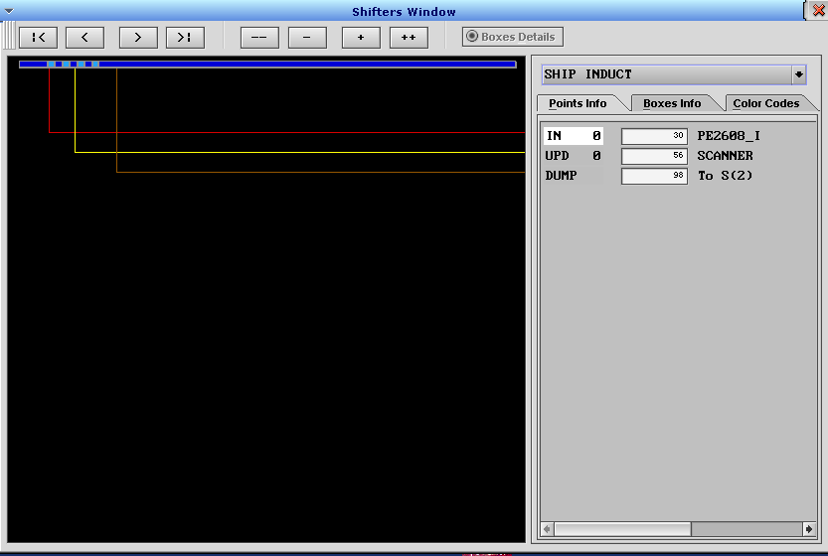
This example shifter has only an Induct, a scan Update point, and a DUMP point. The names to the left of the tick positions reveal the table that holds the configuration: IN = Inpoints, UPD = Updates, OUT = Outpoints. The numeric value is one less than the row number in each table. The names to the right of the tick positions are the names from the first column of each table, except for Inpoints, which uses column Induct I/O Name for that purpose, if it is filled in. DUMP is special – the name to the right is a reference to the row in the Sorters table, so “To S(2)” refers to row 2 in Sorters. “To S(-1)” means the shifter does not dump data to another shifter.

Boxes Info Tab
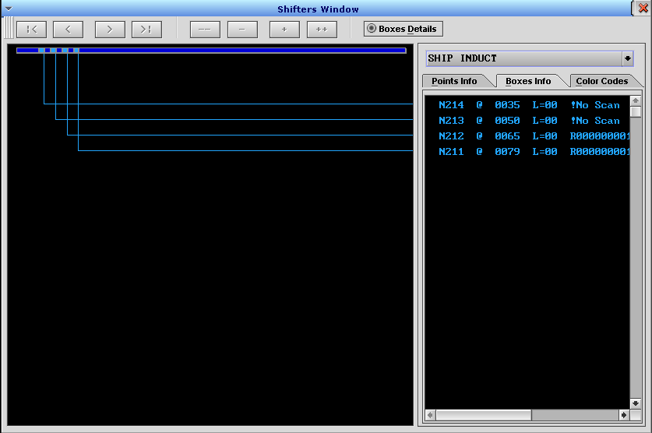
This example shows the Boxes Info tab for the same shifter. The connecting lines link each container image to text that shows information about the current position on the shifter, the lane assignment, and the latest scan or scale data. The lines and text are drawn in the same color as the boxes.
Let’s looking at the last line shown: “N211 @ 0079 L=00 R000000001001” (the end of the line is not visible in the screen shot). “N211” is a reference to the row in the SortData table, column Data Position, where the data for this container is being tracked. “@ 0079” refers to the current tick position along the shifter. “L=00” shows the current lane assignment – a reference to Outpoints_LoLane. “R000000001001” is the last scan received for this container, which may also show scan errors such as “!No Scan”. The container image, the connecting line, and the text in the Boxes Info tab is all shown in blue because no lane assignment has been made. See additional examples in section 8.6, below.

Color Codes Tab
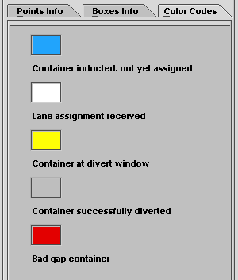
This is the Color Codes tab. The containers on the shifter will be shown in one of these five colors. The normal sequence will be in the order shown: blue as inducted, white when a destination has been set, yellow as it diverts, and grey once it has been divert-confirmed. If a bad gap occurs, both containers will be shown in red.

Points Info Tab – Sorter
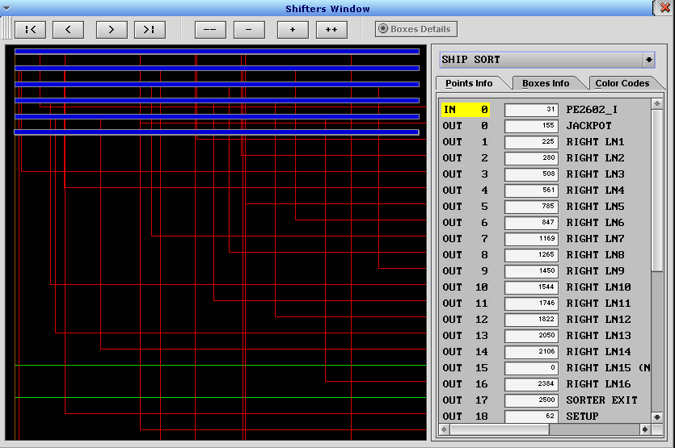
This shifter example, typical of a sorter segment with diverts, has an Induct, numerous Outpoints, and a DUMP point (not visible). Notice the long shifter requires 6 wrapped blue lines to represent the whole thing. The connecting lines cross over the shifter line but stop at the one that matches the tick position of that point. If you click on the point in the right pane, the line will be highlighted with marks to clearly show the point on the shifter.

Additional Shifter Examples
Here are some additional Graphical Shifter window images showing more real-world examples. They are from an older version.
A bad gap being inducted.
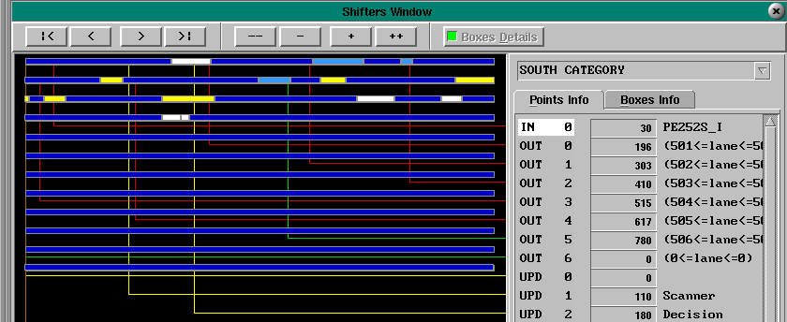
Containers in various states of completion.

Shift Print Log Messages
Scan, Update, Divert, DUMP and other events cause “Shift Print” messages to be written to the FPC log files. These can be very useful in diagnosing problems with shifters. The following table shows the events that will generate these messages, where to find them and the string to search for in the log files:
Tag String | Log File | Event
SFTPRNT | CTRL | A scanner or scale has delivered data. Logged for ScnScanZone_LogLevel >= 1.
update | SORT | An update point input signal has been activated. The signal must be selected in table Updates, column Name. Controlled by Integer Flag #63 TESTSORTER.
verify | SORT | The divert verification signal for a sorter lane has been activated. Controlled by Integer Flag #63 TESTSORTER.
DUMP | SORT | A container has transitioned from one shifter to the next. Controlled by Integer Flag #63 TESTSORTER.
SrtBadGapProcessing | CTRL | A bad gap has been detected.  Logged at all log levels.
HSSawMerge | CTRL | High-speed Sawtooth Merge state has changed.  Logged for HSSawMerge_LogLevel >= 2.
Collision | CTRL | A High-speed Sawtooth Merge collision has occurred. Logged at all log levels.
sawtooth | CTRL | A Sawtooth Merge state change has occurred.  Logged for SawMerge_LogMe >= 2.
Zpr Stop | CTRL | Zipper merge lane has stopped.  Logged for ZipperMerge_LogLevel >= 2.
NOTE: The shift print feature can be controlled by the setting of various log levels and two flags, as defined in the table above. The flags are: Integer Flag #63 TESTSORTER, and New Flags #14 NEWFLAG_SHIFTPRINT. It is recommended you leave these flags at the default value of 1 (ON). NEWFLAG_SHIFTPRINT adds the digits on the nose of the box and the associated log lines that serve as the “key” for those digits.
Each shift print line consists of an abstract snapshot composed of 51 characters representing 51 ticks of the shifter centered on the position of the event. The direction of conveyor flow is from left to right. Each character has meaning. You can extract each type of string from the logs using the grep command with the Tag String, as noted in the detail sections below.
The center character is where the event took place. It can have three different values:
Center Character | Meaning
X | A container was located at the event point.
? | No container was present at the event point.
x | The event has an error, such as a Gap Abort.
The “-“ (hyphen) characters represent empty shifter space – no container is present at that tick.
The “+” (plus) characters represent a normal container present at that tick, as measured by the Induct photoeye.
The numeric character (“1” or “2” in the example) represents the first tick of the container (the nose). They serve to distinguish the containers and refer to additional log messages that appear in the log file before the SFTPRNT line.
If a Bad Gap occurs, the container will be represented by “=” (equal) characters instead of “+”.

SFTPRNT Events
Example Scan Event log messages:
SFTPRNT SCANSHIP: -----++++++2-------++++++X++1----------------------
SFTPRNT SCANSHIP: NOBOX: -----++++++2-------------?-++++++++++1-------------
SFTPRNT SCANSHIP: ---------------------- NOSCAN ---------------------
SFTPRNT SCANSHIP: ---------------------- NOSCAN Dv ------------------
The literal string “SFTPRNT” begins the message. To extract all similar lines from the CTRL log for this scanner, use something like this:
grep “SFTPRNT SCANSHIP” ProjectCTRL.24
SCANSHIP is the scanner’s name from table Machine.
The SFTPRNT message is generated when the scan arrives from the scanner. The scanner will send it when the physical container tails out of the scanner’s photoeye (the scanner’s photoeye is not a device in FPC). If the scanner update point is adjusted incorrectly, the SFTPRNT will “miss” the container image, producing a NOBOX shift print like this:
SFTPRNT SCANSHIP: NOBOX: --------------+++++++++1-?-------------------------
The NOBOX will usually be followed by a NOSCAN event once the container passes the scan point.
To correct this, decrease the tick position value for the scanner update point until the scan arrives while the container is over the scan point.
These messages are generated for ScnScanZone_LogLevel >= Level 1.

Update Events
Example “update” Shift Print log message:
update 3 2 -----------------++++++++X+1-----------------------
The literal string “update” begins the message. To extract all similar lines from the SORT log for this update point, use something like this:
grep “update 3 2” ProjectSORT.24
In the example, 3 is the record number for the shifter in table Sorters and 2 is the record number for the update point in table Updates.
These messages are generated when Integer Flag #63 TESTSORTER = 1.

Verify Events
Example “verify” Shift Print log messages:
verify 3 4 -----------------++++++++X+1-----------------------
verify fail 3 4 -----------------++++++++X+1-----------------------
The literal string “verify” or “verify fail” begins the message. To extract all similar lines from the SORT log for this verify point, use something like this:
grep “verify 3 4” ProjectSORT.24
In the examples, 3 is the record number for the shifter in table Sorters and 4 is the record number for the update point in table Outpoints.
The second example is associated with a divert-confirm failure where the verify input was in the opposite of the expected state. See section 11 for details on how to configure divert confirms.
If Outpoints VerifySENSE = “Is On”, the shift print will be generated when Outpoints Verify I/O Name comes on, even if the container images have not reached the verify outpoint position.
These messages are generated when Integer Flag #63 TESTSORTER = 1.

DUMP Events
Example “DUMP” Shift Print log message:
DUMP from 3 to 4 -----------------++++++++X+1-----------------------
The literal string “DUMP from” begins the message. To extract all similar lines from the SORT log for this point, use something like this:
grep “DUMP from 3 to 4” ProjectSORT.24
In the example, 3 and 4 are the record numbers for the upstream and downstream shifters in table Sorters.
The DUMP message is triggered when the physical container breaks the beam at the dump photoeye. If it is adjusted incorrectly, the DUMP will “miss” the container image, producing a shift print like this:
DUMP from 3 to 4 -------------------------?----++++++++++1----------
The container image is ahead of the physical position. Increase the dump point tick position to correct the issue.
These messages are generated when Integer Flag #63 TESTSORTER = 1.

SrtBadGapProcessing Events
Example “SrtBadGapProcessing” Shift Print log messages:
SrtBadGapProcessing: BADGAP: 3, -----------------++++++++X+1-----------------------
The literal string “SrtBadGapProcessing: BADGAP:” begins the message. To extract all similar lines from the CTRL log for this point, use something like this:
grep “SrtBadGapProcessing: BADGAP:” ProjectCTRL.24
In the example, 3 is the record number for the shifter in table Sorters.
These messages are generated at all log levels.

HSSawMerge Events
Example “HSSawMerge” Shift Print log message:
HSSawMerge: Mrg1, Ln1, St1, -----------------++++++++X+1-----------------------
The literal string “HSSawMerge:” begins the message. To extract all similar lines from the CTRL log for this point, use something like this:
grep “HSSawMerge: Mrg1, Ln1” ProjectCTRL.24
Mrg1 is from HSSawMerge_Name, Ln1 is from HSSawLane_Name, and St1 is from HSSawState_Name.
These messages are generated for HSSawMerge_LogLevel >= Level 2.

Collision Events
Example “Collision” Shift Print log message:
Collision: Mrg1, Ln1, St1, Gap: 9 -----------------++++++++X+1-----------------------
The literal string “Collision:” begins the message. To extract all similar lines from the CTRL log for this point, use something like this:
grep “Collision: Mrg1, Ln1” ProjectCTRL.24
Mrg1 is from HSSawMerge_Name, Ln1 is from HSSawLane_Name, St1 is from HSSawState_Name, and 9 is from HSSawLane_pGapSpaceFnd.
These messages are generated at all log levels.

Sawtooth Events
Example “sawtooth” Shift Print log message:
sawtooth(MERGE1) Ln1 -----------------++++++++X+1-----------------------
The literal string “sawtooth” begins the message. To extract all similar lines from the CTRL log for this point, use something like this:
grep “sawtooth(MERGE1)” ProjectCTRL.24
MERGE1 is from SawMerge_Name, and Ln1 is from SawLane_Name.
These messages are generated for SawMerge_LogMe >= Level 2.

Zpr Stop Events
Example “Zpr Stop” Shift Print log message:
Zpr Stop: ZLn1 -----------------++++++++X+1-----------------------
The literal string “Zpr Stop:” begins the message. To extract all similar lines from the CTRL log for this point, use something like this:
grep “Zpr Stop: ZLn1” ProjectCTRL.24
ZLn1 is from ZipperLane_Name.
These messages are generated for ZipperMerge_LogLevel >= Level 2.

Shift Print Alignment
When extracting Shift Print messages from the log files, you may notice that some align on the leading (right) edge of the container and some on the trailing (left) edge of the container.
Right Alignment
As containers are introduced to shifters at Induct and DUMP points, they are detected at the leading edge. The shift print images will align on the right, like this:
DUMP from 3 to 4 --------------------+++++X+1-----------------------
DUMP from 3 to 4 --------------+++++++++++X+1-----------------------
DUMP from 3 to 4 ---------------++++++++++X+1-----------------------
DUMP from 3 to 4 ------------------+++++++X+1-----------------------
Left Alignment
Scanners are almost always configured to send their scans upon tail-out from the scanner’s photoeye so the scans are delivered at a consistent point, even if a NoRead occurs. The shift print images will align on the left, like this:
SFTPRNT SCANSHIP: -------------------++++++X+++++1-------------------
SFTPRNT SCANSHIP: -------------------++++++X+++1---------------------
SFTPRNT SCANSHIP: -------------------++++++X++1----------------------
SFTPRNT SCANSHIP: -------------------++++++X++++++1------------------

Interpreting CTRL and SORT Log Data
When diagnosing issues with sorters, it is often helpful to reconstruct the sequence of events from the log files. Scan events are written to the CTRL log. DUMP events are written to the SORT log. Correlating the two can be a bit of a challenge, especially if there are many containers on the sorter during the period of interest.
In the CTRL log, find the scan event of interest, usually by the scan value. Note the timestamps for the log messages, the ndx and SHFT values.
The SHFT value is the row number in table Sorters for the shifter in question.
The ndx value is a reference to Data Position in table SortData for the shifter in question (taken from the box image in table SortBuff, column Index).
Since the range of ndx values is limited for each shifter, the values will get reused. You must use the timestamp to which instance of the ndx value is associated with the events in question. Knowledge of the size of the sorter and the time it takes for a container to travel the length of the sorter will be helpful, but generally look for events with the same ndx value within a minute of the scan event.
In the SORT log, find the appropriate time range and look for the matching ndx (sometimes Ndx) and SHFT values to find DUMP and Divert events. A real example is shown in the following screen shots.
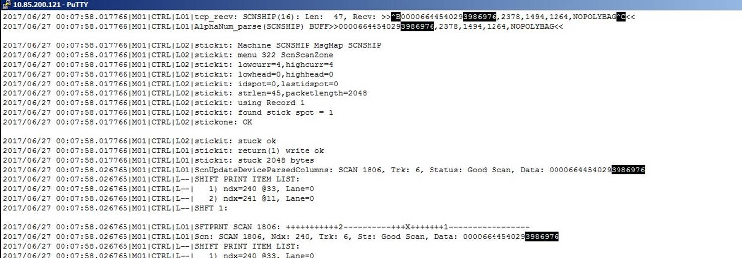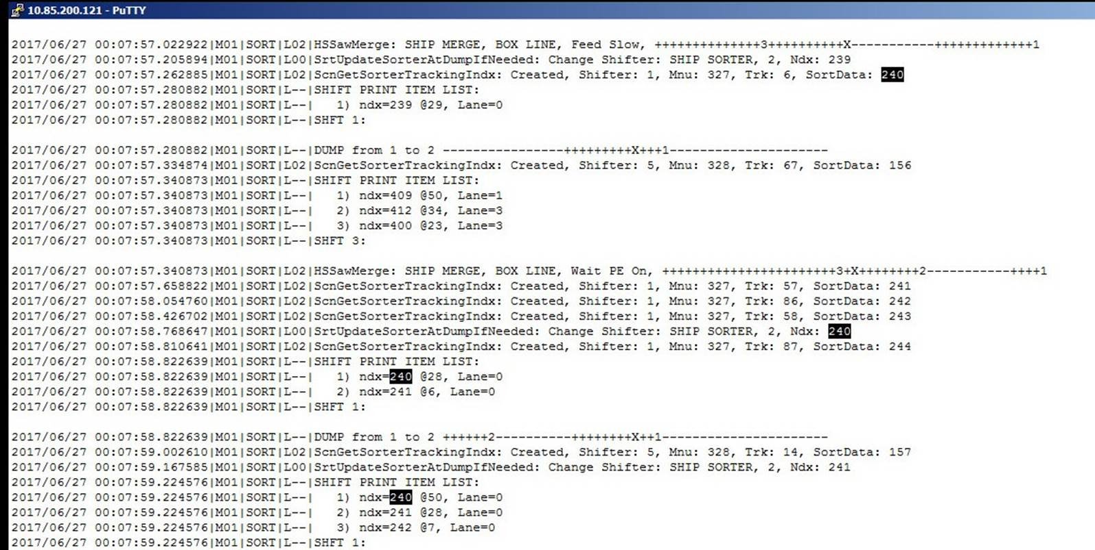
CTRL Log – Scan Event
Use time stamp to find the lines for a single scan event.
SORT Log – Dump Event
Use time stamp to find the lines for a single dump event.
Matching NDX and shifter, within 1 minute time interval

Divert-Confirm Options
The sorter divert-confirm logic can handle several different physical input configuration options.
Divert-confirm events can be set to register only upon success, or on both success and failure.
Divert-confirm events occur as the trailing edge of the container passes through the verify update point.
Supported configurations include:
- Trigger the divert-confirm with the same output used to fire the mechanism. This popular option is simple, and often at least as reliable as the other methods. The drawback is a container that physically fails to divert will still be registered as diverted if the divert mechanism was fired. Divert-confirm failures can only be generated if the divert mechanism is not fired – for bad gaps, and when no lane is available.
- Trigger the divert-confirm using a photoeye across the divert lane. This method requires careful configuration to detect the container within the window defined by the motion of the container image past the assigned tick position of the verify update point on the main sorter line even though the container has left the belt and may change speed as it makes the turn. The extra variability may result in both false positives and false negatives. Both successful and unsuccessful diverts can be reported.
- Trigger the divert-confirm using a photoeye across the main sorter line by detecting the absence of the container there for a successful divert. This has the slight advantage over a photoeye on the divert lane, as the container will reliably reach the detection point on schedule if it fails to divert. Another advantage of this method is that a single photoeye on the main sorter line can be used to confirm multiple lanes, though the divert-confirm events registration time will not be consistent relative to the actual physical divert. It is recommended that one such photoeye be used on each shifter segment when using this method so the containers do not have to pass a dump point before registering their divert-confirm. Both successful and unsuccessful diverts can be reported.
- Trigger the divert-confirm in the special case where the CRR message response from CommCore arrives too late. A divert-confirm failure message will be sent if no destination has been received by the time the container arrives at the SrtScanBoss TooLateUpdatePt if Verify_DCM_FAIL = Y is set for the Outpoints entry. If Verify_DCM_FAIL = N, no message will be sent. In either case, the container will not divert if the destination arrives too late. This is most often used with double-sided shoe sorters, where the TooLateUpdatePt is placed just before the shoe pull-over update point.
The following table describes the results for divert-confirm configuration options in table Outpoints.
Verify SENSE | Verify _DCM_FAIL | Verify I/O Name State | Logical Box | Result
Is On | N | ON (physical box present) | At verify point | Divert-confirm is registered with iDCComplete = 1 (DCM success)
Is Off | N | ON (physical box present) | At verify point | No divert-confirm is generated
Is Off | Y | ON (physical box present) | At verify point | Divert-confirm is registered with iDCComplete = 12 (DCM failure)
NOTE: Do not use Verify_DCM_FAIL = Y unless CommCore is configured to interpret the iDCComplete message field. If CommCore is not configured to interpret that field, it will register any DCM as a successful divert!
NOTE: Do not use VerifySENSE values of “Trans On” or “Trans Off” – they are not currently supported.
NOTE: If multiple outputs are configured to fire, the divert-confirm must be configured on the output that matches the row in table Outpoints where the divert-confirm is configured to be detected (Verify I/O Name is set and ArmFriend = 0).

Configuring a Divert-Confirm Photoeye
Follow this procedure to quickly configure a divert-confirm photoeye using the graphical shifter window.
- Place a container on the conveyor.
- Stop the conveyor as soon as the divert-confirm photoeye is blocked by the container.
- Use the Graphical Shifter Window to determine the location of the photoeye by clicking the “Box Info” tab on the right side of the screen.
- Record the location value shown in the second numeric column for the box on the screen. We will refer to this value as CL, below.
- Measure the physical distance from the nose of the box to the photoeye in inches. We will call this NoseToPE, below.
- Find the Ticks Per Foot value in the Encoders table for this shifter. Divide by 12 to get ticks per inch. We will call this TicksPerInch, below.
- Calculate the new verify point as Verify Location = CL – (TicksPerInch * NoseToPE).
- Set the new Verify Location in table Outpoints.
- Run some more containers.
- If you are using VerifySENSE = “Is On”, adjust the Verify Location until the shift print shows the X within the first three ticks of the box.
- If you are using VerifySENSE = “Is Off”, force Outpoints Outpoint I/O Name OFF so the divert will fail. Run a container through.
- Check the shift print. If the photoeye was blocked before the logical container reached the verify point position, the X will be on the nose of the box. If the logical container reached the verify point before the photoeye was blocked, the X will be somewhere within the box.
- Adjust the verify point position until the X falls three ticks into the box.
- Don’t forget to remove the force on Outpoints Outpoint I/O Name when you are finished.

Divert-confirm Result Codes
In the DCM message, the iDCComplete field contains a numeric code value indicating the DCM status. As discussed above, CommCore must be configured to accept and interpret this field before attempting to use the Verify_DCM_FAIL feature. For sorters, the success code value is 1 and the failure value is 12. Other values are possible in other circumstances. These are the only values currently supported.
iDCComplete Value | Description
1 | Successful divert-confirm for a sorter or transfer.
5 | Divert to a FPC-configured local exception-handling lane for a sorter. Seldom used.
10 | Successful verify at a verification scanner at the lane for a sorter or transfer. Seldom used.
11 | Transfer divert-confirm with timeout error.
12 | Divert-confirm failure for a sorter or transfer. Will occur if the lane is unavailable, if there was a bad gap, if it was determined that the container did not reach the destination lane when it was expected to, or, for a sorter, if the destination information arrived too late.

